CACHE MAPPING

Cache Memory is a unique, exceptionally rapid memory. It is utilized to accelerate and synchronizing with fast CPU. Cache memory is costlier than primary memory or plate memory, however conservative than CPU registers. Cache memory is a speedy memory type that goes about as a cushion among RAM and the CPU. It holds as often as possible mentioned information and directions, so they are promptly accessible to the CPU when required.

Cache memory is utilized to decrease the average time to get to information from the Main memory. The Cache is a littler and quicker memory which stores duplicates of the data from now and again utilized fundamental memory areas. There are different diverse free reserves in a CPU, which store directions and information.

There are 3 types of cache mapping, which are implemented in this project:

1. DIRECT 2) ASSOCIATIVE 3) N-WAY

METHOD TO RUN THE CODE

The code is implemented in python language. The file should be operated in command prompt.

Steps:

1. Go to the directory where the code is saved
2. Run the code as Python main.py

After the code runs you have to select the required operation for the type of mapping and input the necessary information.

After inputting the necessary information, you have options to work on the cache as required by you.

The address if added if replaced with some other is printed that there is replacement occurred.

ABOUT CACHE STORING

The cache is empty at starting with null at positions. The addresses and blocks are added on the basis of input addresses in the respective lines.

The cache is actually is a 2-D array with blocks present in it.

ASSUMPTIONS

Following assumptions were taken into account while implementing the code that:

1. The main memory is of 128 words and All the working is in binary
2. Each word is equal to 32 bits i.e. 1 word == 32 bits
3. Addresses inputted are not wrong and are of the required length
4. When a cache is missed it is added in cache and the printed
5. When a cache is hit it is printed that a cache is present and the required data is printed.
6. Initially the cache memory is empty, with null values present
7. The inputs must be there in a new line one after another with a size of 32 bits each

DIRECT MAPPING WORKING

Following is the working of direct mapping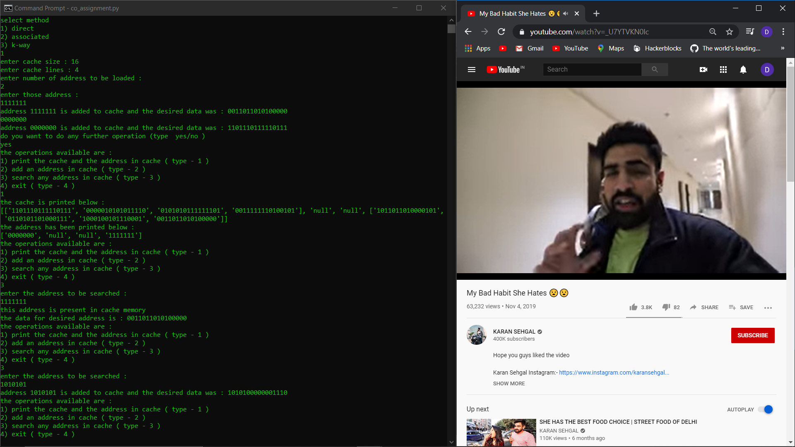

ASSOCIATIVE MAPPING WORKING

Following is the working of associative mapping

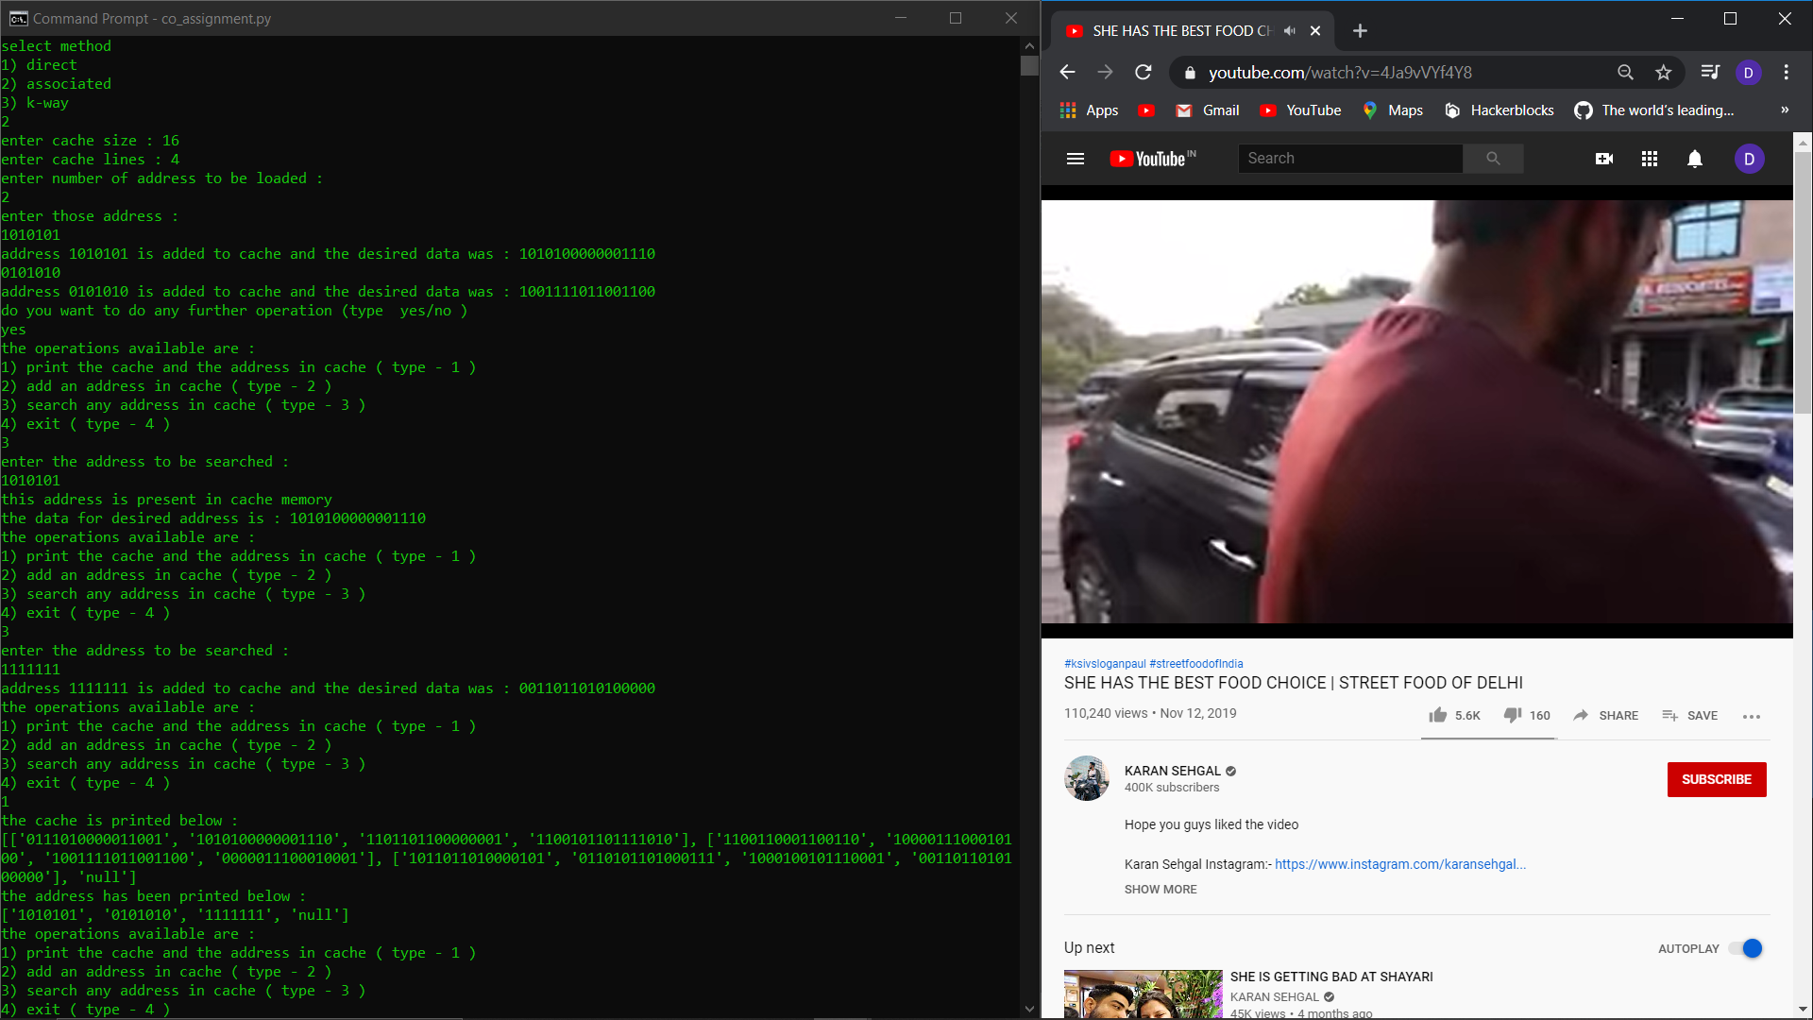

N-WAY MAPPING WORKING

Following is the working of n-way mapping

